**SUGGESTED STRUCUTRE**

InfoStories: What barriers do women face in looking for a job and in keeping one?

Based on World Employment and Social Outlook – Trends for Women 2017 (Authors: Steven Tobin, Stefan Kühn, Sheena Yoon, Richard Horne, RESEARCH Department)

# 1 Women are more likely to be unemployed, in low-quality jobs or outside the labour force.

*Text + infographic + photo?*

**Data from WESO – Trends for Women 2017 (Chapter 1)**

* Globally, the unemployment rate for women stands at 6.2 per cent in 2017, representing a gap of 0.7 percentage points from the male unemployment rate of 5.5 per cent.
* In the Arab States and Northern Africa, unemployment rates among women exceed 20 per cent, more than twice the rate of their male counterparts
* The female rate of vulnerable employment, at 43.3 per cent, is only marginally higher than the male rate but the type of vulnerable employment that men and women do is different.
* Globally, 14.9 per cent of employed women are contributing family workers, compared with 5.5 per cent of employed men. Own-account work represents around 37 per cent of male employment, compared with 28.4 per cent of female employment.
* The current global labour force participation rate for women at just over 49 per cent is nearly 27 percentage points lower than the rate for men (with no improvements anticipated in 2018) – we predict a slower “narrowing” of the gap.

# 2 These gender gaps exist despite a general preference of women to work in paid jobs.

*What do women and men think in your country?*

*Text + photo + Gallup interactive chart*

**Data from ILO-Gallup report:**

* Irrespective of their employment status, 70 per cent of women prefer to work at paid jobs.

**Material to “recycle”:**

* [Interactive chart](http://www.ilo.org/global/about-the-ilo/multimedia/maps-and-charts/enhanced/WCMS_546424/lang--en/index.htm)
* [Press release on the ILO-Gallup report](http://www.ilo.org/global/about-the-ilo/newsroom/news/WCMS_545963/lang--en/index.htm)

# 3 Whether a woman works or not, looks for a job or stays home, is not only determined by her country’s level of economic development.

*Text + photo*

**From WESO – Trends for Women 2017 (Chapter 2)**

* Average female labour force participation rates and income per capita, 2016 (Figure 4, page 22)
* Analytical framework of labour market outcomes (Figure 5, page 24)

# 4 Preconceptions: There is still a lot of people who think it is “unacceptable” for a woman to have a paid job

**Data from ILO-Gallup report:**

* 20 per cent of men and 14 per cent of women think it is not acceptable for a woman to work outside of the home.

**Material to recycle:**

* Video: [The story of Abeer Abu Ghaith: a leading young Palestinian businesswoman](https://www.youtube.com/watch?v=j-e16wN-t3o&list=PL52393B3C2D2785CC&index=13)
* Video: [Empowering women in business and management](https://www.youtube.com/watch?v=k63oI6jdTfk&index=26&list=PL52393B3C2D2785CC)

# 5 Having a spouse or partner makes women less likely to be on a paid job or look for one.

*Text + infographic + photo?*

**Data from WESO – Trends for Women 2017 (Chapter 2)**

* That is true everywhere but in developing countries, where the effect is reversed: partnerships/marriage have a positive effect on participation (3.3 percentage points). This finding highlights the economic necessity to work, despite partnership status, in developing countries.

# 5 While having children may not be determinant, lack of affordable care for families has a significant impact in women’s presence in the labour force.

*Text + infographic + photo?*

**Data from WESO – Trends for Women 2017 (Chapter 2)**

* Globally, the lack of affordable care for children or family members affects women’s participation negatively. In ASNA countries, it decreases the probability to participate by 6.2 percentage points (the highest); in developing countries by 4.8 percentage points; and in developed countries by 4.0 percentage points.

**Material to recycle**

* Video: [USA: Unpaid maternity leave - the harsh reality for many working women](https://www.youtube.com/watch?v=ME64x4YxlZQ&list=PL52393B3C2D2785CC&index=30)

# 6 In developing countries, limited access to safe transports is the greatest obstacle to women’s participation in labour markets.

*Text + infographic + photo?*

**Data from WESO – Trends for Women 2017 (Chapter 2)**

• Globally, the lack of affordable care for children or family members affects women’s participation negatively. In ASNA countries, it decreases the probability to participate by 6.2 percentage points (the highest); in developing countries by 4.8 percentage points; and in developed countries by 4.0 percentage points.

**Material to “borrow” or video as an example of what we could do?**

* [Daily Commute Another Challenge for Pakistan's Working Women](https://www.youtube.com/watch?v=wyXJEDQwBak)

# 7 Gender roles deriving from religions may also reduce the odds of finding women at paid jobs, or looking for one, in developing countries.

However, the results are mixed in developed and emerging countries.

*Text + infographic + photo?*

**Data from WESO – Trends for Women 2017 (Chapter 2)**

● Religions embody a complex system of values that extends to gender roles. **In developing countries, the probability to participate is substantially reduced by religion (-10.9 percentage points), a proxy indicator for more restrictive gender role conformity**. In developed and emerging countries, the results are mixed: in some cases the effect is positive, in others negative.

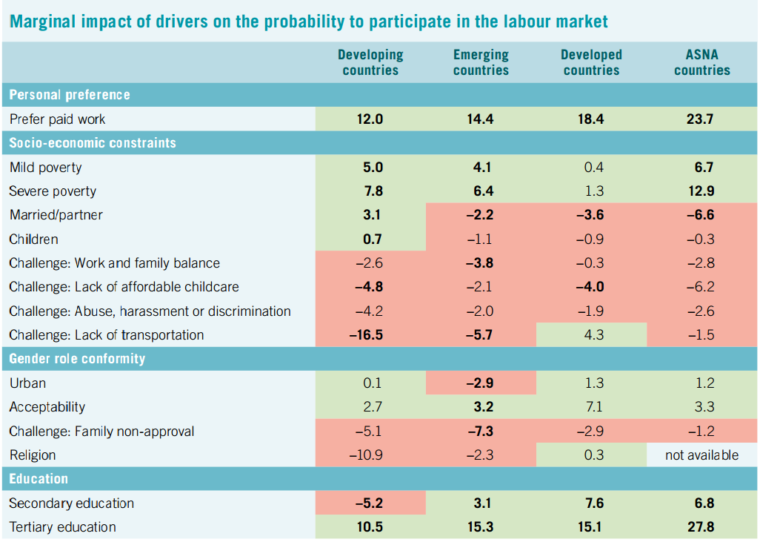

# Comments/questions:

• Do we discuss other barriers? Or things that help women, like education/skills? (see table below for other findings)

• How do we present the percentage points of the “marginal effects”? It’s too complicated to actually explain how these numbers were generated. At the same time, with no figures at all, aren’t we diminishing the results/our research? Should we have a video with Stefan and Sheena explaining their work?

• Do we add something on policy in the end?